To: Premier Danielle Smith
Cc: Minister of Environment and Protected Areas, Sonya Savage
CC: Minister of Energy, Pete Guthrie

Dear Premier Smith;

I am writing to you on behalf of The Crowsnest Conservation Society.

The CCS is a not-for-profit organization based in the Crowsnest Pass, and devoted to ensuring a healthy future for the natural environment in the region surrounding our community and the people and wildlife that live within it. We are a local group with conservation of the natural environment as a primary purpose. We held our first meetings in 2004, were incorporated in 2005, and became a registered Charitable Organization with Revenue Canada in 2009. Most members of our Society, many of them lifetime members, are local residents in the community; they remind us that there is no better place, anywhere, for children to grow and flourish. Our volunteer board members reflect a broad cross section of the community. We feel privileged to contribute our time, talent and enthusiasm to applying the environmental conservation principles set out in our mission statement and strategic planning document.

It was with a great deal of concern and sadness that CCS received the information that Window Mountain Lake has been contaminated with dust from the coal mines across the border in BC. Window Mountain Lake is a favorite destination here for both residents and tourists because of its beauty. It sits in a pristine, wild meadow at the base of a spectacular peak, at the farthest reaches of headwaters of the Oldman Watershed. When you look at it, it seems impossible to believe that it could be polluted.

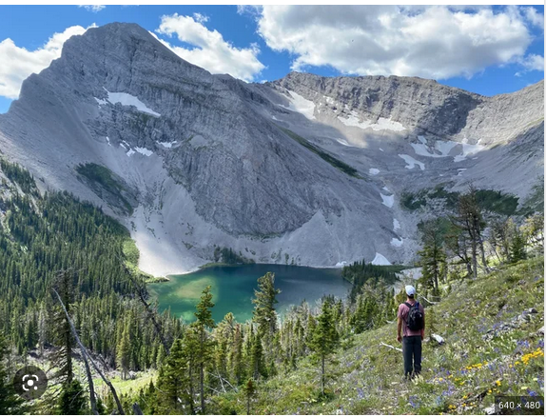

Unfortunately, it sits less than 10 km downwind from Teck’s Elkview Coal Mine at Sparwood.
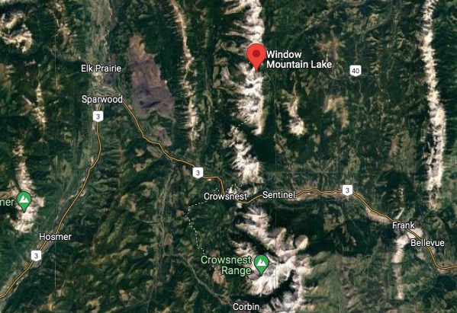

As you can see in this map, even the high peaks along the Continental Divide have not been able to contain the dust that is generated from mountain top removal mining.

CCS is writing today to ask you to do two things. First, please release the data on snowpack contamination around Window Mountain Lake. If scientists, industry, and communities are going to be able to do anything to deal with the problem, first they will need the data.

The second thing we would like to ask is that the Alberta Government continue to enforce the ministerial order blocking coal mining exploration development. Better yet, legislate it. Until it is clear that the contaminants from open pit and mountain top coal mining can be contained, there is so much more to be lost than gained from allowing it in our landscape.

Thank you for your time. We will look forward to your response.

Yours truly,
Brenda Davison
President of Crowsnest Conservation Society

